

LjunggrenAudio RYO Ampmix
A 4-channel amplifying mixer in 8hp

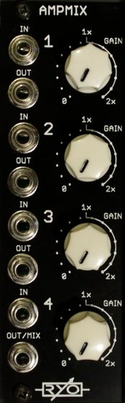

- 4-channel amplifying high precision mixer/attenuator.
- works as 4 channel mixer, 1 attenuator + 3 channel mixer, 2 attenuators + 2 channel mixer or 4 attenuators.
- 2.0x gain (6dB) per channel, channels can be chained for greater gain, any combination of channels in any order. (16x gain, 24dB)
- 5.0V offset per channel.
- All analogue circuitry.
- hi-fidelity signal chain with low noise opamps.
- high impedance inputs and buffered outputs.
- slim 8HP footprint.
- compact 35mm Depth (with power cable attached).
- low power draw: 22mA +12V / 22mA -12V / no +5V required.
- Works for audio as well as CV.
- Fast responding CV inputs allow for complex modulation and modulating with audio signals.
- sum mix output.
- ch1 output normalized to ch2 input for patching convenience.

downloads
* user manual
* quickstart guide
* assembly guide
* hi-res schematic
* datasheet
* BOM

